Information about property intended for sale.
«Agrarian Credit Corporation» JSC carries out the sale of property accepted on the balance sheet through an auction for price increase/decrease and direct sales according to the list:
№  p/n | Name | Brief characteristics | Location | Photo of the object
 | A building with printing equipment and a land site of 0.102 (ha) cadastral number 21:319:014:020 | Total area 639.9 sq. meters with equipment | Astana city, Saryarka district, st. Ykylas Dukenuly, building 6 | 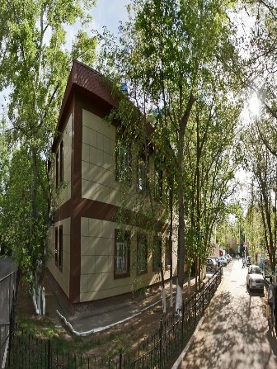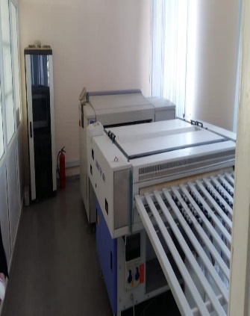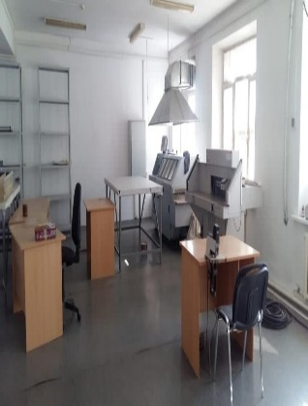
 | Greenhouse complex (without registration of buildings) | Two land sites with areas of 6.76 ha. (on temporary land use rights) and 3.24 ha. (owned).  Cadastral number of the land site No. 06:088:046:380 and cadastral number of the land site No. 06:088:058:472, respectively. | Zhambyl region, Zhambyl district, Karatobe rural district, Baiterek village, Amankeldi TN, site 183* | 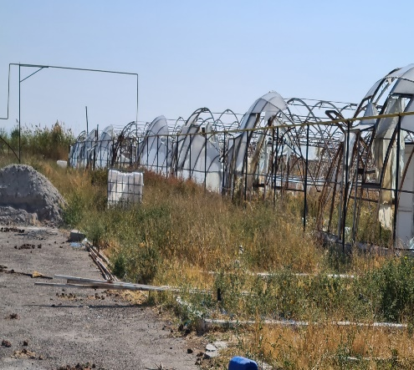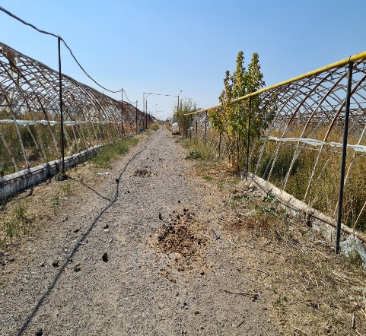
 | Greenhouse complex | The total area of ​​the greenhouse 49,619.67 sq.m. with a land site of 9 ha. Cadastral number of the land site No. 06:088:058:396 | Zhambyl region, Zhambyl district, Karatobe rural district, Baiterek village, Amankeldi TN, site 81* | 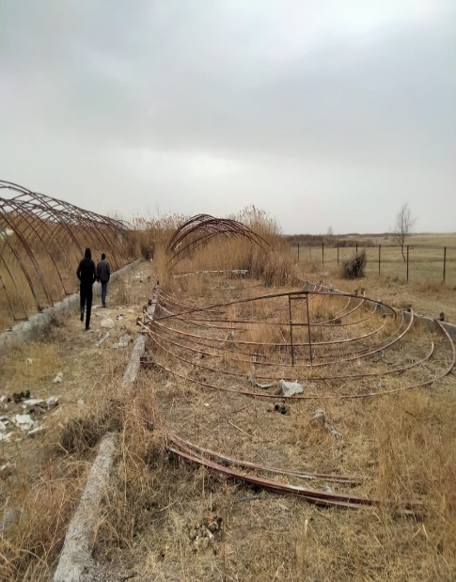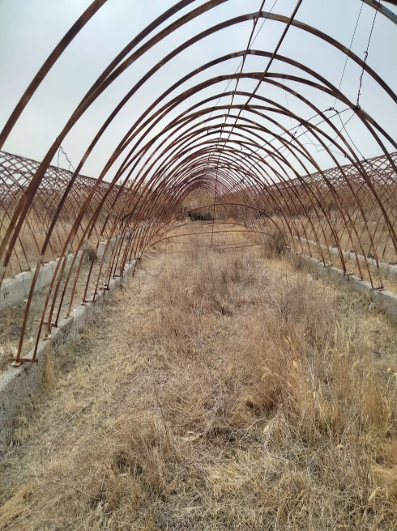
 | Land site | Land site with an area of ​​5 ha., cadastral number (19-309-215-023), divisible site, intended purpose of the site is for farming. | Shymkent city, Karatau district, block 215, block 215,023 | Photo of the land site is not attached
 | Land site | Land site with an area of ​​50. (ha), cadastral number (19:294:048:113), divisible site, intended purpose of the site of land for agricultural purposes | Turkestan region, Otyrar district, Koksarai village, st. Koksarai, block 048 K, site 113 | Photo of the land site is not attached
 | Land site | Land site with the right of temporary paid land use, with a total area of ​​33,339 ha., including arable land 11,574 ha., pastures 21,765 ha., cadastral number 01-172-039-017 | Akmola region, Birzhan Sal district, Enbekshilder rural district | Photo of the land site is not attached
 | Land site | Land site with an area of ​​4 hectares with cadastral number 01:011:018:400, with the intended purpose of constructing a residential area | Kosshy city, Akmola region. | Photo of the land site is not attached
 | Land site | Land site with a total area of ​​3934 (ha), cadastral number 15:167:016:036, intended purpose of conducting commercial agricultural production at the address: North Kazakhstan region, Akzhar, district. Talshyk village | North Kazakhstan region, Akzhar, district. Talshyk village | 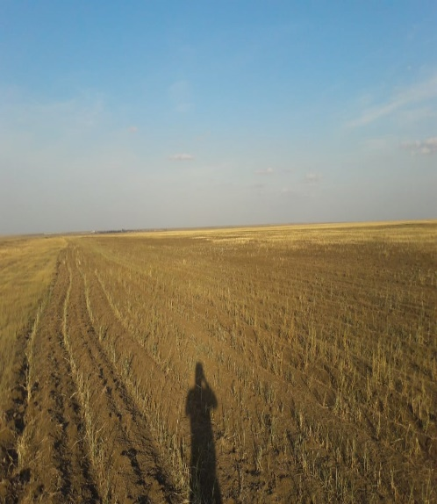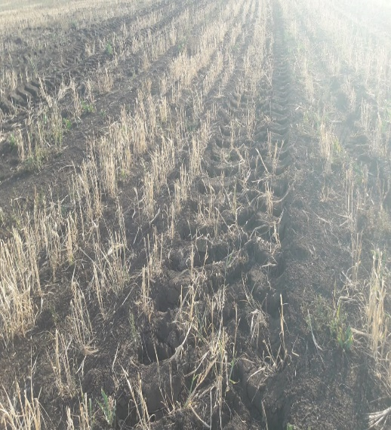

For real estate, the Company considers the option of selling it in installments with a down payment.
For all questions, please contact the indicated telephone numbers.

Tlebaldin Murat, telephones: 7 (7172) 55-99-92, ext. 3011; 8 747 485 55 74, email. address Tlebaldin.M@agrocredit.kz
Igisenova Aliya, telephones: 7 (7172) 55-99-61, ext. 3180; 8 707 240 70 82, email. address Igisenova.A@agrocredit.kz

Motor vehicles
 | Motor vehicle Chevrolet Captiva, national number 892AX01, engine 2997 cc, body number (VIN code) XWWCD2659EU003210, year of manufacture 2014 silver metallic, fixed assets 2 units. | Contact the branch of Agrarian Credit Corporation JSC in 19/1 Turan Ave. Edem BC, Astana
 | Motor vehicle Ssang Yong Kyron, national number 449АI12, engine 2295 cc, body number (VIN code) KPTS0A16SDP185403, year of manufacture 2013, white. | Contact the branch of Agrarian Credit Corporation JSC in building No. 225, 29 microdistrict. Aktau

